IT DR Plan AIS Services

IT DR Plan AIS Services
Plan
January 2026

Table of contents
1. DR and BCP Document Library 3
2. Related Documentation 3
3. Purpose 3
4. Scope 3
5. System Overview 3
5.1 Overview 3
5.2 Vendor Support/Key Contacts 4
6. Technical Documentation 4
6.1 System Architecture 4
6.2 Critical Dependencies 7
6.3 Pre-requisites to cutover to Global Storage 8
6.5 Installation and set-up (Barebones rebuild) 9
7. Recovery Strategy 10
7.1 Partial DR Strategy 10
7.2 Enterprise/Full DR Strategy 12
8. Recovery Runsheet 12
9. Outstanding Issues 13
10. Document History 13

DR and BCP Document Library
AIS DR Documentation

Related Documentation
Please use this link to access MW established DR and BCP processes such as GEMS & MIM.
Melbourne Water - Emergency Management

Purpose
A disaster recovery plan (DRP) is a structured and documented approach that outlines how an organisation can quickly resume its operations after an unplanned incident. A DRP is a crucial part of the business continuity plan (BCP) for AIS Services.
Below are the scenarios for this DRP:
- Loss of any or all of the Melbourne Water Azure Australia Southeast region services that make up the AIS Services technical architecture.

Scope
The scope of this document covers:
- Azure services required to run cross-region AIS Disaster Recovery
- Data replication processes
- Automatic and manual Failover processes for all AIS services
- Azure resource build processes using Azure DevOps
- Roles and responsibilities during a DR exercise

System Overview

Overview
Melbourne Water is transforming its integration landscape by adopting Azure Integration Services (AIS) in the production Azure environment. This cloud-first approach replaces traditional BizTalk server-based integrations and establishes a modern, resilient architecture for applications such as TechOne, Pega, and Altus Project Online.
This implementation leverages a suite of key Azure Integration Services to deliver a robust, scalable, and secure enterprise-grade solution. The Azure services used to build this architecture that are required for DR are:
- Logic Apps
- Function Apps
- Service Bus
- Event Hub
- Event Grid
- Storage Accounts
- API Management Services
- Key Vault
- Data Factory
The goal of the Azure Integration Services platform is to allow centralisation of Melbourne Water Azure integrations enable scalability and flexibility of adding more integrations in the future. The services form a cohesive integration layer that supports both event-driven and request-response communication patterns, aligning with modern cloud-native architecture principles.

Tier Rating and Recovery Requirements for AIS Services:
RTO | RPO | Tier Rating
24 | 24 | 2

Vendor Support/Key Contacts
Component | Company | First Contact Details |  | Escalation Contact Details |  | Account Manager Contact Details |  | Support Hours | Comments Provided during the event
 |  | Email | Phone # | Email | Phone # | Email | Phone #
Azure Services  Cloud Operations Team | NCS | IT.CloudOps@melbournewater.com.au |  | chris.mills@au.ncs.co | +61 481 619 109 | stuart.clift@au.ncs.co | +61 422 672 551 | TBA
Azure Services  Microsoft Support | Microsoft | N/A |  |  |  |  |  | 24x7 | Issues logged at:  https://support.microsoft.com/contactus
TechOne | Technology1 | Andrew.King@technology1.com |  |  |  |  |  | Monday – Friday 9am-5pm | All external details related to TechOne SFTP and API integration.
Vago SFTP | Vago | matthew.dolan@audit.vic.gov.au |  |  |  |  |  | Monday – Friday 9am-5pm | All external details related to Vago integration.
Visa SFTP | Visa | mcathari@visa.com |  |  |  |  |  | Monday – Friday 9am-5pm | All external details related to Visa integration.
Westpac SFTP | Westpac | ivan.matanovic@westpac.com.au |  |  |  |  |  | Monday – Friday 9am-5pm | All external details related to Westpac integration.
ExpenseMe Pro | Inlogik | desmond.pushparaj@inlogik.com |  |  |  |  |  | Monday – Friday 9am-5pm | All external details related to ExpenseMe Pro integration.
eCloud SFTP | eCloud | Himanshu.negi@exedee.co.nz  Minhaz.Chhiboo@exedee.co.nz  support@exedee.com |  |  |  |  |  | Monday – Friday 9am-5pm | All external details related to eCloud SFTP integration.
eCloud API | eCloud (exedee) | Himanshu.negi@exedee.co.nz  Minhaz.Chhiboo@exedee.co.nz |  |  |  |  |  | Monday – Friday 9am-5pm | All external details related to eCloud API integration.
Altus Project Online | Sensei | Nate Boudoukos <Nate.Boudoukos@Sensei.Cloud> |  |  |  |  |  | Monday – Friday 9am-5pm | Sensei Cloud support.

Technical Documentation

System Architecture
The APIM has been newly built as part of the AIS project. A new Public IP address has been allocated, and appliances such as Web Application Firewall (WAF), on-premises firewall, and Cloud Firewall needs to be updated to allow the new Public IP. This makes it important to understand the traffic flow and the intervening devices that fall along the way, so that the configuration changes can be documented and executed during migration.
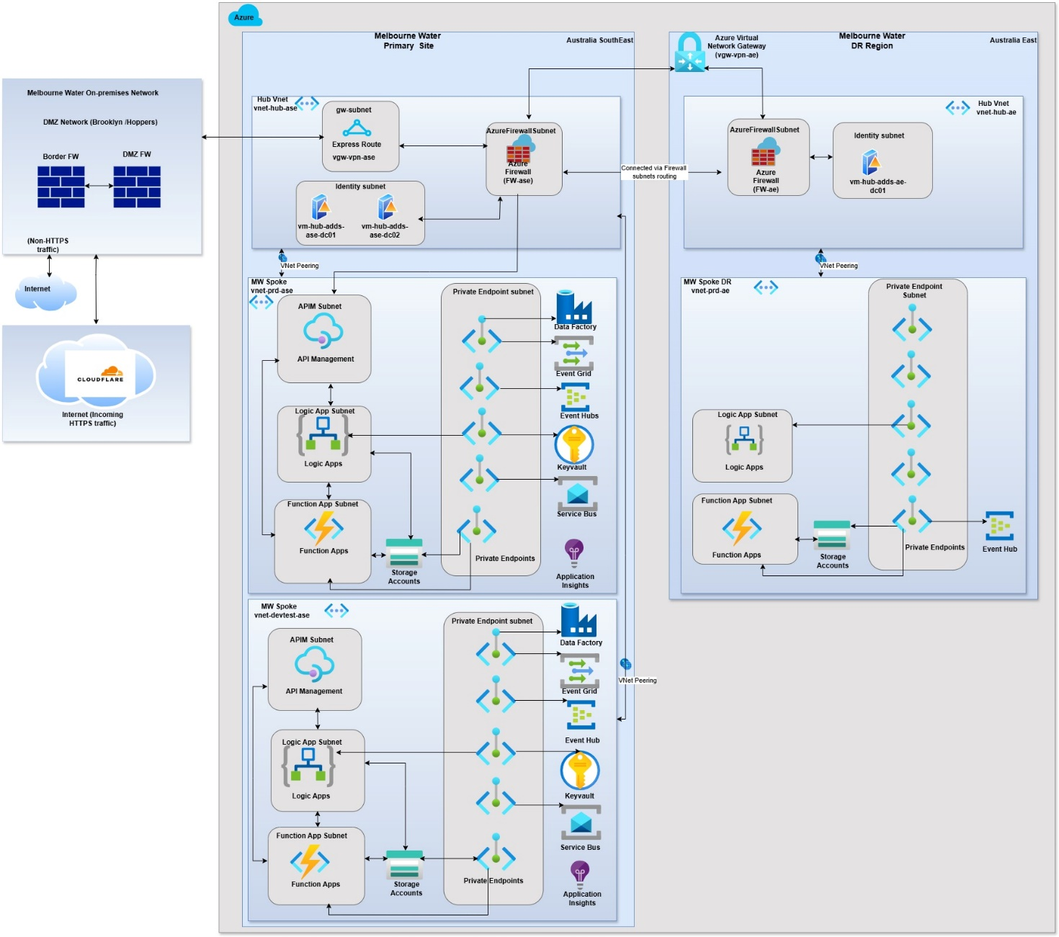
The current networking in place will route traffic from Cloudflare -> on-premises DMZ -> ExpressRoute -> Azure Firewall -> Azure APIM.
Web Application Firewall: CloudFlare, Cloud Flare – Ingress, Cisco Umbrella- MW-Outbound.

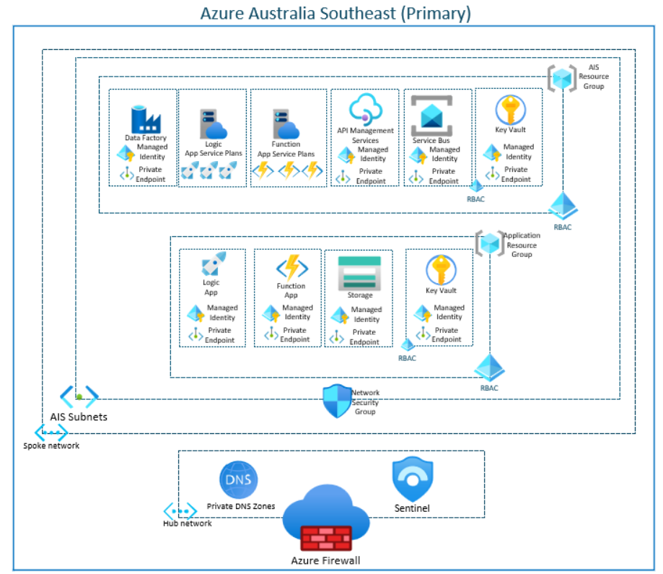
The diagram illustrates the architecture of the Azure Australia Southeast region, which serves as the primary environment for Azure Integration Services (AIS). At the core of this setup is the AIS resource group, which hosts shared services such as Data Factory, Logic App and Function App service plans, API Management, Service Bus, and Key Vault. These components form the backbone of the integration platform, enabling secure and scalable communication between systems.
Each downstream application, such as TechOne, Pega, or Altus Project Online, resides in its own dedicated resource group. This design ensures logical isolation and governance while still allowing controlled access to AIS core services. Applications connect to AIS resources through private endpoints and managed identities, which eliminate the need for credentials and maintain traffic within the Azure Virtual Network for compliance and security.
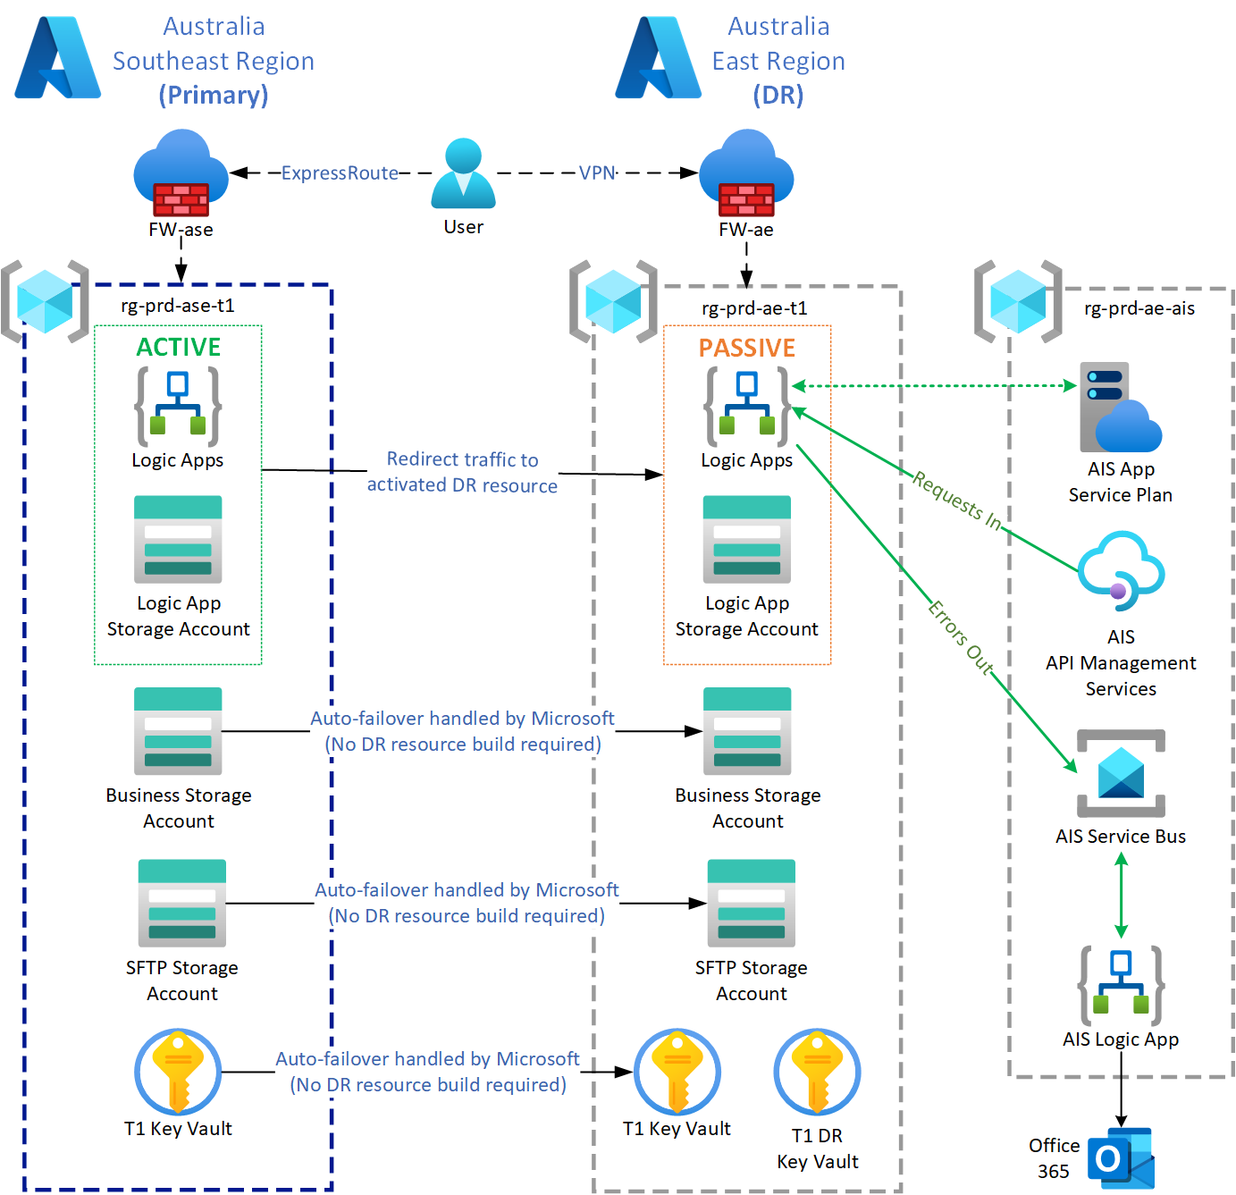

Resource Name | Azure Service | IP Address | Application
evhns-prd-ae-ais | Event Hubs Namespace | 172.27.20.10 | AIS
func-prd-ae-ais | Function App | 172.27.20.8 | AIS
func-prd-ae-ais-asp | App Service plan | N/A | AIS
logic-prd-ae-ais | Logic App (Standard) | 172.27.20.9 | AIS
logic-prd-ae-ais-asp | App Service plan | N/A | AIS
stprdaeaisapp | Storage account | 172.27.20.5  172.27.20.7  172.27.20.4  172.27.20.6 | AIS
apim-prd-ase-ais  (Geo-DR) | API Management | 172.26.16.5  172.27.16.4 | AIS
evgt-prd-ase-ais  (Geo-DR) | Event Grid | 172.26.18.7  172.26.18.6 | AIS
kv-prd-ase-ais  (Geo-DR) | Key Vault | 172.26.18.4 | AIS
sbns-prd-ase-ais  (Geo-DR) | Service Bus | 172.26.18.8 | AIS
adf-prd-ase-ais | Data Factory | 172.26.18.5 | AIS
stprdaseais | Storage Account (Business) | 172.26.18.11  172.26.18.9  172.26.18.10  172.26.18.12 | AIS
Logic App (eCloud) (Standard) | logic-prd-ae-ecloud | 172.27.20.19 | TechOne
Logic App (empro) (Standard) | logic-prd-ae-empro | 172.27.20.20 | TechOne
Logic App (nabfp) (Standard) | logic-prd-ae-nabfp | 172.27.20.23 | TechOne
Logic App (vago) (Standard) | logic-prd-ae-vago | 172.27.20.21 | TechOne
Logic App (westpac) (Standard) | logic-prd-ae-westpac | 172.27.20.24 | TechOne
Logic App (sentinel) | logic-prd-ae-sentinel | 172.27.20.29 | TechOne
Storage account (Business) | Stprdaset1bus  (GRS) | 172.27.20.22  172.27.20.25  172.27.20.27  172.27.20.26 | TechOne
Storage Account  (sftp) | Stprdaset1extsftp  (GRS) | 172.27.20.11 | TechOne
Storage Account  (Logic Apps) | Stprdaet1logic  (LRS) | 172.27.20.16  172.27.20.13  172.27.20.15  172.27.20.14 | TechOne
Key Vault | kv-prd-ase-t1  (Geo-DR) | 172.27.20.18 | TechOne
Logic App | logic-prd-ae-pega | 172.27.16.13 | Pega
Key Vault | kv-prd-ase-pega  (Geo-DR) | 172.27.16.5 | Pega
Storage Account | Stprdasepega  (Geo-DR) | 172.27.16.9 | Pega
Logic App | logic-prd-ae-pol | TBD | Altus Project Online
Function App | func-prd-ae-pol | TBD | Altus Project Online
Key Vault | kv-prd-ase-pol  (Geo-DR) | TBD | Altus Project Online
Storage Account | stprdasepol  (Geo-DR) | TBD | Altus Project Online

Critical Dependencies
Identify all the system specific dependencies for this plan to work.
This section should outline all the critical information regarding software, server replication, and stand-up sequence to ensure that the system can be restored within acceptable timeframes.
Type | Details
Hardware | N/A – Entirely Cloud based.
Software | The AIS platform must first be restored or confirmed functional prior to downstream applications (TechOne, Pega, Altus Project Online) DR pair activation. This includes these services:  - Logic Apps  - Function Apps  - Service Bus  - Event Hub  - Event Grid  - Storage Accounts  - API Management Services  - Key Vault  - Data Factory
Network & Connectivity | Production region: Azure ExpressRoute  DR region: VPN  Production Firewall: FW-ase (Australia Southeast)  DR Firewall: FW-ae (Australia East)  Azure DNS Private Resolver  Azure Private DNS Zones  Azure Private Endpoints
Access Management | Identity management service provided by Microsoft Entra ID. Users will need to access the following Azure locations:  Subscriptions:  - 1.MelbWater-PRD  - 0.MelbWater-Shared-Svcs  Resource Groups:  - rg-prd-ae-t1  - rg-prd-ase-t1  - rg-prd-ae-pega  - rg-prd-ase-pega  - rg-prd-ae-pol  - rg-prd-ase-pol  - rg-hub-ase  - rg-hub-ae  - rg-prd-ase-ais  - rg-prd-ae-ais  - rg-PRD-network-ase  - rg-PRD-network-ae  With the following conditions:  - Contributor or Global Administrator role  - Key Vault Administrator role  - MFA enabled account  From a Melbourne Water office or through an allowed VPN
Data | Azure Storage Accounts in this architecture have all been configured with Geo-redundant storage (GRS) enabled. This feature ensures data redundancy by replicating it to 3 locations within the same region, and 3 locations in a region outside of the Production region’s data centre.
Infrastructure | Microsoft manage all infrastructure as part of the Azure Cloud services.
Upstream | All services in the Microsoft Azure East region need to be up and accessible to enable DR capability for AIS. This would include Microsoft Entra ID services to enable user administrative access to the Melbourne Water Azure tenancy.
Downstream | All Azure AIS Services.

Pre-requisites for cutover
The Australia East DR region Logic Apps and Function Apps require Azure Storage Accounts that are also based in the Australia East DR region as they cannot connect to the primary Azure Southeast region Storage Accounts. The pre-requisites for cutover require resources for Logic Apps, Function Apps, and Storage Accounts to be built in the Australia East DR region with connectivity in place.
These Australia East DR region-based resources have already been built and have met the aforementioned pre-requisites for cutover.

7.4 Complete Technical Documentation
AIS As-built documentation:
- AIS Services Deployment_PROD As-Build v 0.1.docx
TechOne Handover Documents:
- K10417 TechOne Cloud Transition Project - Documents - TechOne Handover Documents - All Documents
- MW - TechOne AIS Integration Detailed Design v1.4.docx
- TechOne_Vago Integration _AS_IS.docx
- TechOne_Visa Integration _AS_IS.docx
- TechOne_Westpac Integration _AS_IS.docx
- TechOne_ExpenseMe Pro Integration _AS_IS.docx
- TechOne_eCloud Integration _SFTP_AS_IS.docx
Pega Handover Documents:
- INT-328 MW Pega Azure Integration Detailed Design v1.1.docx
- Logic Apps Integration - CVS-PEGA - Confluence

Installation and set-up (Barebones rebuild)
AIS resources can be deployed through Melbourne Water’s Azure DevOps environment. The AIS DevOps environment is used for the maintenance of the AIS Azure resources, and core AIS code for Logic Apps and Function Apps.
The DevOps environment can be located here: https://dev.azure.com/mwcloud/AIS
And for application specific DevOps projects:
https://dev.azure.com/mwcloud/TechOne
https://dev.azure.com/mwcloud/Pega
https://dev.azure.com/mwcloud/POL
The core AIS pipelines are stored in a folder called ‘AIS Core’. These pipelines contain all of the AIS resources that are shared between teams.
Note: There are some other pipelines that are used by specific teams, but they are not part of the AIS project specifically.
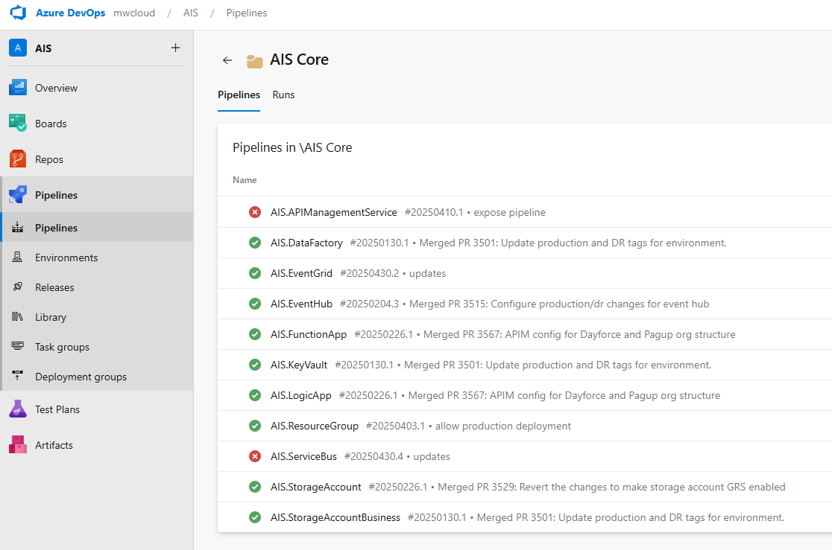
The pipeline for each item is kept in the same folder as the item being deployed. For example, the Key Vault folder is located at: AISServices/main/keyVault, and the Key Vault pipeline is located at: AISServices/main/keyVault/azure-pipelines.yml.
The code is organised into logical folders, each containing a logical part of the TechOne system.
- AIS – This folder is a git submodule that links back to the AIS repository, containing Bicep templates for various types of Azure resource.
- Infrastructure – This folder contains the TechOne specific Bicep code. Each resource that is deployed to the TechOne resource groups has a folder here.
  - keyvault – TechOne Key Vault for storing TechOne specific secrets.
  - logicApp – The base Bicep templates for creating integration specific Logic Apps.
  - roleAssignments – The Bicep code for setting up the role assignments required for the logic apps.
  - storageAccount – The shared storage account that logic apps will use for their operation.
  - storageAccountBusiness – The business storage account that stores files that have been transferred by the integration workflows.
  - storageAccountSftp – A storage account that is configured as an SFTP server to allow some integrations to push files to TechOne remotely.
- templates – The shared DevOps pipeline code, using DevOps templates.
- README.md - The readme which contains pretty much the same information as this document.
Similarly for TechOne,
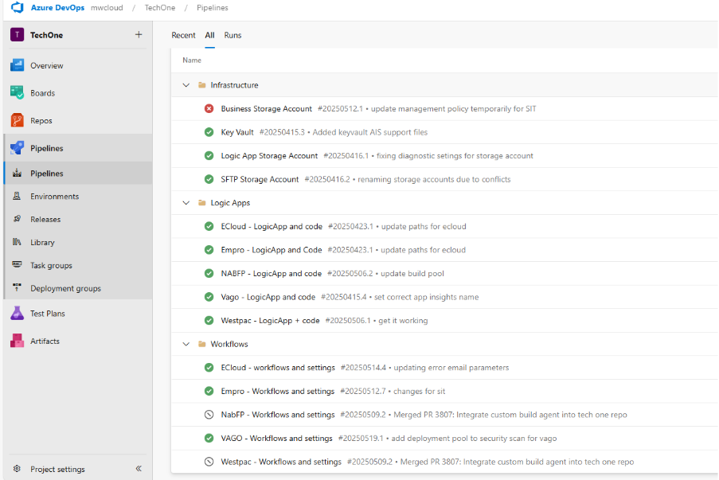
Pega
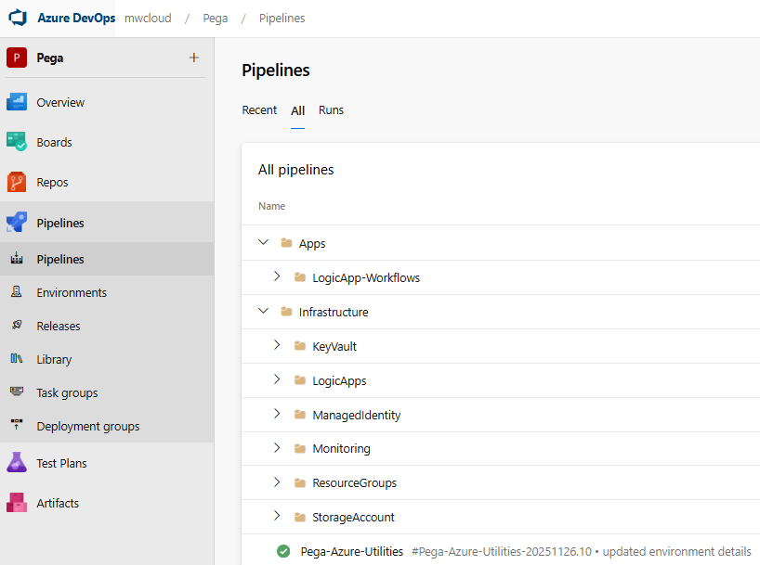
Altus Project Online
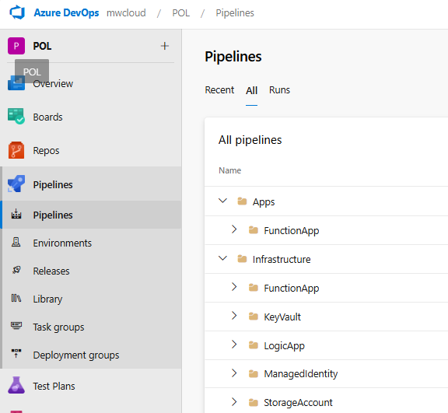

Recovery Strategy
System owners will work with GEMS process to identify the relevant response strategies, based on the scale of impact or the affected component of the system.

Partial DR Strategy
The partial Disaster Recovery Plan will be invoked in the case of an outage of the Azure Australia Southeast region.

The AIS Service Owner needs to immediately advise IT Support (e.g., Cloud Operations, TCS or IT helpdesk), who will determine the cause of the failure.

Document the detailed steps required to restore failed components in the system:
- Key Vault (Automatic Failover)
Key Vault automatically replicates data from the primary to the secondary region and handles failover automatically during outages. This process requires no action. As private endpoints are in use, it may take 20 minutes to re-establish the connection.
In an outage, the requests that are made of Azure Key Vault in that region are automatically routed (failed over) to the secondary region. When the primary region is available again, requests are routed back (failed back) to the primary region.
- API Management Services (Automatic Failover)
Azure API Management has been deployed as a multi-region deployment, which replicates data and will failover automatically. The failover process for this service requires no action.
If the primary region goes offline, the API Management management plane and developer portal become unavailable, but the secondary region continues to serve API requests using the most recent gateway configuration.
- Event Grid (Automatic Failover)
Event Grid services are replicated and fail over automatically. The failover process for this service requires no action.
Event Grid resource definitions for topics, system topics, domains, and event subscriptions and event data are automatically replicated across three availability zones. When there's a regional failure in one of the availability zones, Event Grid resources automatically failover to another availability zone without human intervention. Currently, it is not possible to control (enable or disable) this feature. When an existing region starts supporting availability zones, existing Event Grid resources are automatically failed over to take advantage of this feature.
- Service Bus (Manual Failover)
Service Bus failover must be triggered by Melbourne Water and will never be triggered automatically by Azure.
The Service Bus service has the Geo-Disaster Recovery feature enabled with a paired region (Australia East). The feature ensures that the entire configuration of a namespace (entities, configuration, properties) is continuously replicated from a primary namespace to a secondary namespace with which it is paired and allows initiation of a once-only failover move from the primary to the secondary at any time. The failover move re-points the chosen alias name for the namespace to the secondary namespace and then breaks the pairing. The failover is nearly instantaneous once initiated.
Note: This feature enables instant continuity of operations with the same configuration but does not replicate the messages held in queues or topic subscriptions or dead-letter queues. To preserve queue semantics, such a replication requires not only the replication of message data, but of every state change in the broker, which is offered in the Geo-Replication feature (Public Preview).
- Data Factory (Manual Failover)
In the event of a disaster, Azure Data Factory will be deployed to the Australia East region from existing code builds stored in Azure DevOps. Data Factory data such as blob storage is replicated from the primary region, and the Australia East region deployment will connect to the failed over storage.
- Event Hub (Manual Failover)
Event Hub has been deployed with instances in both the primary and secondary regions. In the event of a region failure, manual intervention is required to connect resources to the Australia East region Event Hub resource (evhns-prd-ae-ais).
- Logic Apps and Function Apps (Manual Failover)
These two services have been deployed with instances in both the primary and secondary regions. They share a dedicated Storage Account in the secondary region and do not require replicated data from the primary region. In a disaster event, traffic manager will need to be re-routed to point to the Azure Australia East region resources:
Resource Name | Resource Type | Resource Group
logic-prd-ae-ecloud | eCloud Logic App (Standard) | rg-prd-ae-t1
logic-prd-ae-empro | ExpenseMe Pro Logic App (Standard) | rg-prd-ae-t1
logic-prd-ae-nabfp | NAB Logic App (Standard) | rg-prd-ae-t1
logic-prd-ae-vago | VAGO Logic App (Standard) | rg-prd-ae-t1
logic-prd-ae-westpac | Westpac Logic App (Standard) | rg-prd-ae-t1
logic-prd-ae-sentinel | Used for sentinel logs ingestion of TechOne activity/access logs | rg-prd-ae-t1
stprdaeAISlogic | Logic App Storage account | rg-prd-ae-t1
apim-prd-ase-ais | API Management | rg-prd-ae-ais
logic-prd-ae-pega | Logic App for Pega integration | rg-prd-ae-pega
logic-prd-ae-ais | Error Handling Logic App (Standard) | rg-prd-ae-ais
logic-prd-ae-pol | Logic App for Altus POL data transformation | rg-prd-ae-pol
logic-prd-ae-ais-asp | Logic App Service Plan | rg-prd-ae-ais
func-prd-ae-ais-asp | Function App Service Plan | rg-prd-ae-ais
func-prd-ae-pol | Function App for Altus POL data transformation | rg-prd-ae-pol

- Storage Accounts (Automatic Failover)
All Production Storage Accounts in this architecture have all been configured with Geo-redundant storage (GRS) enabled. This feature ensures data redundancy by replicating it to 3 locations within the same region, and 3 locations in a region outside of the Production region’s data centre. In the case of a region failure, Azure will failover data automatically to the secondary region with no manual intervention required.

NOTE: Use the run sheet to verify successful restoration of the system.

Enterprise/Full DR Strategy
Decision to invoke full-scale disaster recovery plans will be communicated to system owners through the GEMS process.

Recovery Runsheet
System owners or disaster recovery personnel should use the DR Runsheet to validate the successful recovery of the system. The DR Runsheet is to be used for both planning, testing and actual DR mode.
Link to separate Recovery Runsheet: IT TEM DR Runsheet - AIS Services.xlsx

Outstanding Issues
Issue ID | Issue | Date | ETA | Assigned
1. | DR has not been fully tested | August 2025 | DR test date yet to be scheduled
2.
3.
Document History

Document History
Date | Reviewed/Actioned By | Version | Action
January 2026 | Floyd Reyes  Azure DevOps Engineer | 2 | Added applications consuming AIS services.
June 2024 | Cloud Services and Hosting Lead | 1 | Initial document created and reviewed. Update / Remove non-applicable wordings. Endorsed.

